ACAO Board of Directors Meeting Minutes
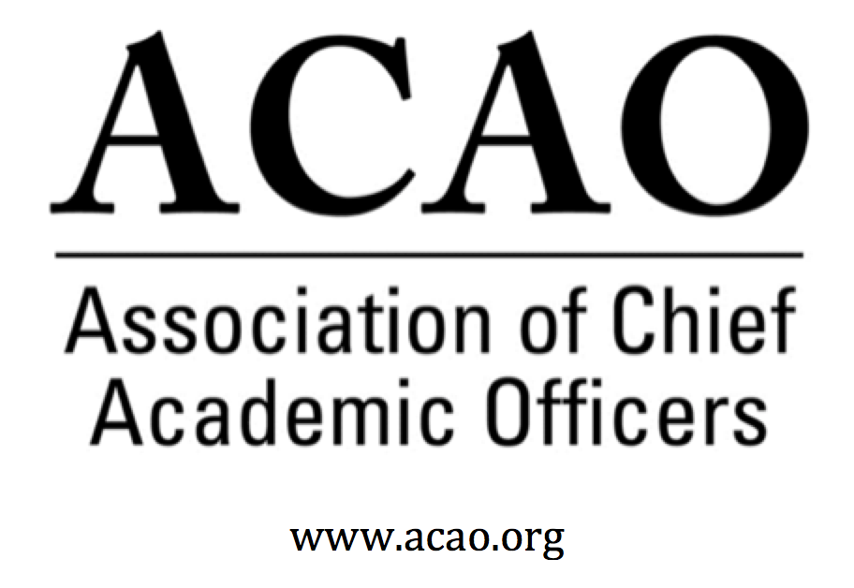

September 4, 2019: https://zoom.us/j/707742741, 2-3 PM (Eastern)

Name | Attend | Name | Attend | Name | Attend
Martha Potvin | Yes | Laura de Abruna | No | Michael Evans | Yes
Kathy Johnson | Yes | Peter Nwosu | Yes | David Manderscheid | Yes
Mary Boyd | Yes | Gregory Ochoa | Yes | Scott Newman | Yes
Gail Baker | Yes | Michele Wheatly | Yes | Constance St Germain | Yes
Andrew Shean | Yes | Connie Johnson | Yes | Patricia Salkin | Yes
Charles Cook | No | Laura Woodworth-Ney | Yes | BJ Reed, Adv Council | Yes
Beth Ingram | Yes | Lori Werth | Yes | Doreen Murner | Yes

- Review and approval of August Board Meeting Minutes (K. Johnson)
  - No discussions, no changes
  - P. Nwosu motions to approve. 2nd. All in favor. Motion passes.
- Introductions – special welcome to new members, Michael Evans, David Manderscheid, Scott Newman, Patricia Salkin, and Constance St. Germain and to Advisory Council Liaison (and former ACAO President) BJ Reed
  - Virtual Ice Breaker: What opportunity associated with ACAO are you most excited about? OR What are you most looking forward to this year at your own institution?
  - All participants introduced themselves & their institutions and their initiatives or challenges.

- Board of Directors Matters

  - New Directory and Overview of Terms and Assigned Roles (see next page)
  - Leadership Updates: Gail Baker agreed to serve as secretary
  - Proposed Committee Structure/Charge Language and proposed changes to Bylaws
    - Structural changes to committees requested at this time…feedback needed.
    - Membership & Communications Committees combined
    - Nominating and Bylaws blended
    - Program is now called Professional Development with expanded scope
    - Finance Committee, no changes
    - Innovations & Strategies Committee – NEW committee developed to take us forward in scanning higher ed horizon for opportunities
  - No committee changes or suggestions. Seeking chairs for Professional Development and Innovations & Strategies Committees. Suggestion if Advisory Council members might serve on committees in ex-officio capacity.
  - All changes to the bylaws will be approved at the ACE meeting in March.

Membership and Communications (Chair: Greg Ochoa): The purpose of this committee is to oversee and manage communications between the association and its membership (in consultation with ACAO leadership), primarily aimed at recruiting and retaining members. Includes developing member communications that cultivate a distinctive ACAO identity and brand, developing strategies and materials to generate interest in joining ACAO. Members also will use professional contacts to encourage membership, report on membership, and make recommendations about dues. Members will work at generating communications materials and strategies directed toward building membership.
Nominating and Bylaws (Chair: Martha Potvin): The purpose of the Nominating and Bylaws Committee is to both, a) develop and manage the process by which candidates for the governing board are presented to the membership for election (this includes soliciting the membership for nominations and applications for board positions, developing a slate of candidates, and overseeing the election process and informing the membership of the results); and b) review ACAO's bylaws and bring any recommendations for change to the ACAO board of directors for consideration.
Professional Development (Chair: _____): The purpose of the Professional Development Committee is to guide development, coordination and implementation of programming aimed at supporting professional development for chief academic officers. Professional development programming includes sessions or workshops developed alone or in partnership with other higher education organizations, as well as support for peer mentoring and networking activities.
Innovation and Strategies (Chair: ______: The purpose of the Innovation and Strategies Committee is to pursue innovative and entrepreneurial activities consistent with the mission of ACAO. Activities may include pursuit of grants and contracts or the development of new strategic priorities or partnerships that could enhance the academic enterprise across a range of higher education institutions.
Finance (Chair: Mary Boyd): The Finance Committee provides guidance to the board to ensure the financial health of the organization, according to sound fiscal policies. The committee shall periodically review and revise investment policies, financial and audit documents and fiscal policies of ACAO and make recommendations to the board.

Call for changes and for edits…none reported at this time. Needed are committee chairs for missing chairs. Once committees meet chairs will be discussed with ea. committee. BJ Reed mentioned that Advisory Council members could be an asset to committee work. He will discuss with S. Vasquez to see how best to align council members with committees.
M. Boyd asked for more volunteers for Finance Committee
Board member should feel free to send suggested committee language to the boar prior to the full membership vote in March at the ACE meeting.

- Membership & Communications Committee - updates since summer board meeting (Greg Ochoa, et al.)
  - Lapsed members outreach is next week. Additional outreach maybe needed by board directors to call lapsed members, Advisory Council is ready to help too. Work on the value add and benefits of belonging to ACAO were found to be current for ACAO on web and brochures. Suggestion to use some of the work on value add statement to be used in marketing and communications. Testimonials may be helpful.

- Report from Advisory Council (BJ Reed). Council very much appreciates the communications with the board. Under consideration is the Council taking Coffee Hour presentations into a “blog” format to publish on the ACE Engage platform.
- Discussion of Potential ACAO response to AIR/Educause/NACUBO Joint Statement on Analytics (Mary Boyd and Connie Johnson)

  - Educause asked for ACAO statement of support/endorsement. M Boyd & C Johnson will develop. Discussion: so much data, how to balance & take action. How does academics actually use data? How to cultivate data literacy? Caution of misuse of data, data not always factual. What are the effects on under-represented? How to create the expectation that data NEEDS to be used.
  - All agreed ACAO should issue a statement

- Old Business

  - ACAO Blogging for Higher Education Today proceeding well – first two contributions archived in Google Drive
  - ACE Engage partnership updates (Laura Niesen de Abruna and Kathy Johnson)
  - ACE Annual Meeting and Reception for CAOs (Kathy Johnson)
  - Partnership Updates

- New Business

Future Board Meetings: (typically the first Wednesday of the month at 2 PM, eastern); October 2, 2019; November 6, 2019; December 4, 2019 [Note: In-person winter meeting to be held at University of San Diego on March 14, 2020]

Board of Directors: Assigned Roles
Executive Committee | Director | Role/Committee | Institution | Term Ending
 | Mary Boyd | Treasurer/President-Elect | Berry College | 2020/2022
 | Kathy Johnson | President | IUPUI | 2020/2021
 | Doreen Murner | Executive Director | AMC Source | n/a
 | Martha Potvin | Past-President  Responsibility: Chair of Nominating and  Bylaws Committees | Springfield College | 2020
Directors | Gail Baker | Editorial Team  Secretary | University of San Diego | 2022
 | Charles Cook | Membership & Communications | Austin Community College | 2021
 | Laura Niesen de Abruna | PI: Digital Fellows Project  Finance Committee  Editorial Team  Innovation & Strategies | York College of Pennsylvania | 2021
 | Michael Evans |  | Southern New Hampshire University | 2020 (slate in 2020 for 3Y)
 | Connie Johnson | Professional Development  Editorial Team | Colorado Technical University | 2020
 | Beth Ingram | Treasurer-Elect  Membership & Communications | Northern Illinois University | 2021
 | David Manderscheid |  | University of Tennessee, Knoxville | 2020 (slate in 2020 for 3Y)
 | Scott Newman | Professional Development | Oklahoma State University Institute of Technology | 2020 (slate in 2020 for 3Y)
 | Gregory Ochoa | Chair: Membership & Communications | Potomac State College of West Virginia University | 2021
 | Peter Nwosu | Membership & Communications  Innovation & Strategies | Lehman College of CUNY | 2021
 | Patricia Salkin |  | Touro College | 2020 (slate in 2020 for 3Y)
 | Andrew Shean | Innovation & Strategies | National University System | 2022
 | Constance St. Germain |  | Capella University | 2020 (slate in 2020 for 3Y)
 | Sharon Vasquez | Chair: Advisory Council (ex officio) | Provost Emerita, University of Hartford | 2020
 | Lori Werth | Professional Development  Innovation & Strategies | University of Pikeville | 2022
 | Michele Wheatly | Membership & Communications | Syracuse University | 2022
 | Laura Woodworth-Ney |  | Idaho State University | 2022

