ACAO Board of Directors Meeting Minutes
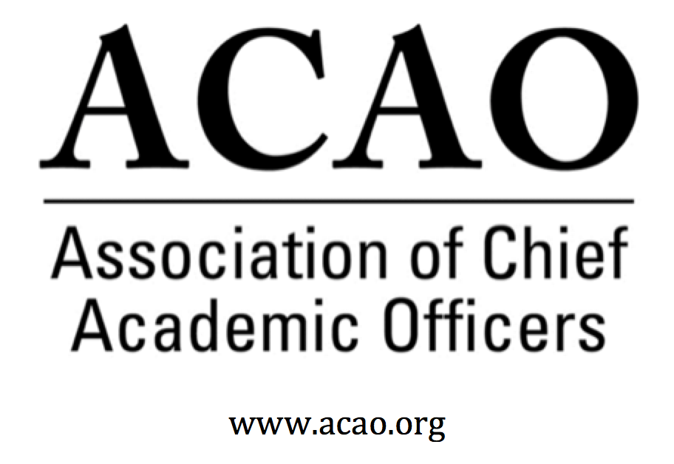

April 3, 2019: https://zoom.us/j/707742741, 2-3 PM (Eastern)

Name | Attend | Name | Attend | Name | Attend
Martha Potvin | Yes | Laura de Abruna | Yes | Michele Wheatly | Yes
Kathy Johnson | Yes | Peter Nwosu | Yes | Laura Woodworth Ney | No
Mary Boyd | Yes | Gregory Ochoa | No | Sharon Vasquez | Yes
Gail Baker | Yes | Patricia Rogers | No
Andrew Shean | Yes | Connie Johnson | Yes
Charles Cook | Yes | Todd Diacon | No
Kelli Brown | Yes | Lori Werth | Yes | Doreen Murner | Yes

- Review and approval of March, 2019 Minutes (K. Johnson)
  - Motion to approve: Laura. 2nd Martha. All in favor, motion passes.

- Review and discussion of attached summarized survey data from March, 2019 Business Meeting to determine priorities for programming, mentoring connections, and partnerships (all)
  - How can ACAO use and support ACE Engage platform Provost blog to create a win for both ACE & ACAO? Kathy will work with ACE for further specifics. ACAO Members Only Listserv is scheduled for April 1 and can be used by members for queries. Consideration to target Coffee Hrs. to NEW CAOs, who may have specific interests/questions/challenges. Ex: Interest in stabilizing enrollment was significant in the survey so maybe Coffee Hr. facilitators work with someone from enrollment management.
  - New Partnerships;
    - Educause – Connie met w John O’Brien and was encouraged with the discussion. Maybe an opportunity for articles or sessions w/provosts.
    - OLC Excellerate – Laura de Abruna asked for digital fellow panel participants to talk about digital transformation
    - CCAS – Martha is working on programming with them for their Nov 2019 meeting.
- Committee and Officer Assignments (K. Johnson) – Timeline for determination of priorities for upcoming year
- Secretary
- Communications/Membership Committee – Advisory Council agreed to help on-board new ACAO members with a quick phone call/email welcoming them to ACAO. Sharon would like a script for the council to use for consistent messaging.
- Bylaws Committee – no update
- Annual Program Committee – the program committee will be expanded to more than just the ACE Annual Meeting. It will also include programming at other relevant associations including sessions and panel discussions.
- Finance Committee – no update
General Discussion: Martha – how can we engage more members to be involved with our committees. Suggestion was to use the listserv to create a call for volunteers.

- Updates on Advisory Council Activities (S. Vasquez)
  - Council has potential agenda topics for future coffee hrs.
    - Enrollment management – recruitment (with a guest presenter).
    - Program review & reassessing viability (reprioritization of programs)
    - Series targeting new provosts
    - Change management (new programs, new enrollments, business models all changing)
Does focus on on-line portfolio management differ from on-campus portfolio management? Are there other methods of distribution?
Council members could use the listserv to “seed” potential coffee hr. questions.
Kathy asked for a good mentoring model & what does it look like: Establish times for interaction during conference meetings. Monthly calls. E-communications. May need a consideration for small v large school mentoring. And it has to have a valued purpose. Suggestion to match by institutional types (get bios of mentors). Mary suggested mentoring CAOs who experience “unplanned transitions”. Kathy will develop mentoring guidelines and use committees as deployment.
Since Sharon is now an ex-officio board member, Connie Johnson will phase out as Advisory Council Liaison.

- Website content development and solicitation of CAO blog posts (ACE Engage)
  - Content needs to be refreshed and updated with current issues for provosts. Maybe a digest of the ACE blog or parts of the member survey or campus experiences (Ex: Confucius Institute, political and campus challenges). Connie, Laura de Abruna and Lori agreed to take a look at the web site and make suggested updates.

- Google Drive site for ACAO archives
  - All board directors have access to the ACAO G Drive:
https://drive.google.com/drive/folders/1Eah5zZxEzPu_dKVf3P9EDWWgciThK-2n?usp=sharing

- ACAO Member Listserv (launched 4/1/19) – discussion of board of directors/advisory council engagement
  - Kathy will schedule each board director for a specific month to seed the listserv with a quick question.

Future Board Meetings: (typically the first Wednesday of the month at 2 PM, eastern)
- May 1, 2019 2:00pm ET, June 5, 2019 2:00pm ET, July 19 (tentative) in person @ ACE Headquarters, Washington DC
- Doreen to connect with ACE to see if we can move the meeting to July 18th.

Standing Committee Descriptions:

- Communications and Membership: The purpose of this committee is to oversee and manage communications between the association and its membership (in consultation with ACAO leadership), primarily aimed at recruiting and retaining members. Includes developing member- communications that cultivate a distinctive ACAO identity and brand, developing strategies and materials to generate interest in joining ACAO. Members also will use professional contacts to encourage membership, report on membership, and make recommendations about dues. Members will work at generating communications materials and strategies directed toward building membership.
- Nominating: The purpose of the Nominating Committee is to develop and manage the process by which candidates for the governing board are presented to the membership for election. This includes soliciting the membership for nominations and applications for board positions and developing a slate of candidates. The Nominating Committee is also responsible for overseeing the election process and informing the membership of the results
- Annual ACE Programming: The purpose of the Annual Program Committee is to coordinate the program held at the annual meeting. Committee members will identify topics and coordinate speakers and program activities relevant to CAOs and CAOs/presidents/chancellors in the academic and higher education area.
- Bylaws: The bylaw committee is charged with reviewing ACAO's bylaws and bringing any changes/recommendations to the ACAO board of directors for consideration.
- Finance: The Finance Committee provides guidance to the board to ensure the financial health of the organization, according to sound fiscal policies. The committee shall periodically review and revise investment policies, financial and audit documents and fiscal policies of ACAO and make recommendations to the board.

Executive Committee | Director | Role/Committee | Institution | Term Ending
 | Kathy Johnson | President | IUPUI | 2020
 | Kelli Brown | President-Elect  2019-20 Responsibility: Chair of ACE Program Committee | Georgia College and State University | 2021
 | Doreen Murner | Executive Director | AMC Source | n/a
 | Martha Potvin | Past-President  2019-2020 Responsibility: Chair of Nominating Committee | Springfield College | 2020
Directors | Gail Baker | Finance | University of San Diego | 2022
 | Mary Boyd | Treasurer | Berry College | 2020
 | Charles Cook | Membership & Communications | Austin Community College | 2021
 | Laura Niesen de Abruna | PI: Digital Fellows Project  Finance Committee | York College of Pennsylvania | 2021
 | Todd Diacon | Nominating | Kent State University | 2020
 | Connie Johnson | ACE Program | Colorado Technical University | 2020
 | Gregory Ochoa | Chair: Membership & Communications | Potomac State College of West Virginia University | 2021
 | Peter Nwosu | Membership & Communications | Lehman College of CUNY | 2021
 | Patricia Rogers | n/a | Winona State University | June, 2019
 | Andrew Shean | Program | National University System | 2022
 | Sharon Vasquez | Chair: Advisory Council (ex officio) | Provost Emerita, University of Hartford | 2020
 | Lori Werth |  | University of Pikeville | 2022
 | Michele Wheatly | Program | Syracuse University | 2022
 | Laura Woodworth-Ney |  | Idaho State University | 2022

