ACAO (VIRTUAL) Members Business Meeting Minutes
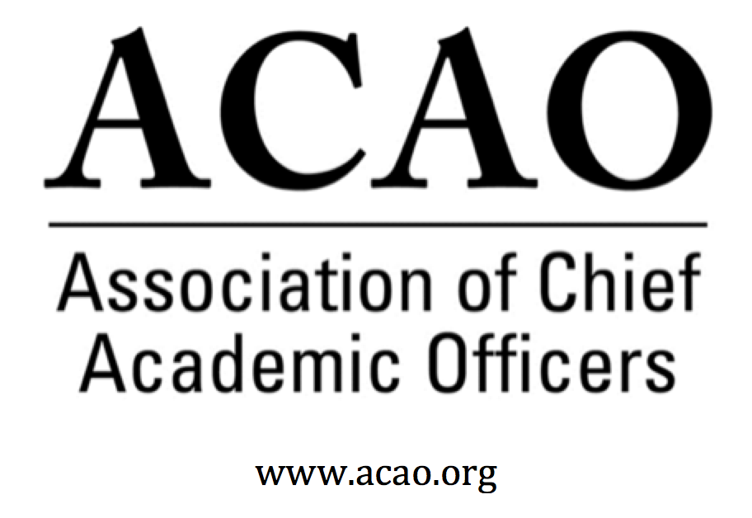

July 14, 2020, 1-2 PM (Eastern). Zoom Link:

Attendees:

Constance St Germain | Devin Byrd | Lori Werth
Mary Boyd | Robert Jones | Risa Dickson
LorI Werth | Rafael CAnizales | Prabha Thajeta
Connie Johnson | Better Bergeron | Robert Moreschi
Michael Quillen | Loredana Haeger | Nancy Parsley
Kathy Johnson | Rob Ducoffe | Carey McDougall
John McCarthy | Andreia Nebel | Scott Bennie
Greg Ochoa | Vernon Smith | Carol Ertwig
Scott Newman | Ellen Granberg | Kathleen Williamson
Pam Stinson | Heather Coltman | Christina Clark
Laura de Abruna | Constance St. Germain | Selma Botman
Michael Evans | Shawnda Floyd
Beth Ingram | Ed O’Connor
Peter Nwosu | Paul Blake
Andrew Shean | Pranesh Aswath
Patricia Salkin | John Zomchick
Gail Baker | Wayne Jones

Welcome!
  - Certification of February Board Elections/Introduction of ACAO Board Members (M. Boyd)
    - Self introductions including institution name. ACAO serves all sectors of higher ed & it is evidenced by the diversity of institutions on this call.
    - M. Boyd: Since our March meeting was cancelled, we will virtually certify the Feb 2020 board election. Introduction of Exec Committee & new board directors. There were no objections by members.

- ACAO Financial Position (B. Ingram)
    - B. Ingram noted ACAO has an approved 2020 budget. $70k in revenue, about $67K in expenses for an income of $3k. Largest expense is paid to AMC Source for back office support, membership maintenance, web maintenance, etc. On track to meet the budget.
    - L. de Abruna noted the BMGF grant has $26k left which will be spent when travel and events are feasible. Amount will carry-forward to next yr.

- ACAO Bylaw updates – Membership Vote to approve (K. Johnson)
    - K. Johnson discussed minor changes to the bylaws, mostly in changing committee names to align with the work of the board. Motion to approve bylaw changes. 2nd L de Abruna. Poll was displayed for members to vote. Quorum is present with over 2/3 voting YEA. Motion passes.

- ACAO Advisory Council – recognition of contributions and activities (K. Johnson)
    - Council is comprised of retired CAOs and they are active. They converted “Coffee Hr” webinars into blogs for Higher Ed Today (ACE’s blog). They created and executed “Ask A Provost” and continue to provide guidance to the board. Thanks to the Advisory Council for all their work for ACAO.

- Review of 2019-20 Activities – (K. Johnson; L. deAbruna)
K. Johnson reflected on previous yr framed around communications & collaboration. Communications-new members listserv, website updates, polling feature, increase in social media presence. Collaboration-meet with orgs that are aligned with CAOs, Educause, ACE for provost focused blogs and Engage Platform space for ACAO. Also worked with groups for the future pipeline of provosts with presentations on Preparing for the Provost Role.
L. de Abruna-Digital Learning Cmte. Tyton Partners survey webinar July 21st. APLU resource the COVID-19 Playbook. New grant in partnership with APLU for about $200K to provide 3-4 webinars for CAOs on what was done & learned in virtual learning and for developing teams on digital learning.

C. Johnson thanked both Kathy & Laura for their leadership.

Break-out into Mini-Town Halls

- Professional Development (Mini Town Halls) – topic specific discussion on current issues & events affecting CAOs. Will be placed in zoom break out rooms. Select one of the topics below during the meeting.

  - The Role and Influence of the CAO in Improving Diversity and Inclusion
    - Facilitators: Ellen Granberg and Peter Nwosu
  - Opportunities and Challenges in Launching Fall 2020: Serving the 21st Century Learner
    - Facilitators: Scott Newman and Connie Johnson
  - Academic Affairs and Student Affairs: An Integral Partnership in 2020
    - Facilitators: Lori Werth and Pam Stinson

Meeting Adjourned

