ACAO Board of Directors Meeting Minutes
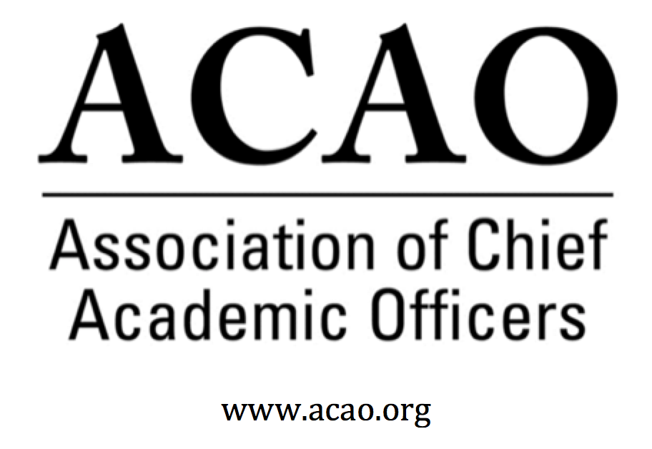

February 5, 2020: https://zoom.us/j/707742741, 2-3 PM (Eastern)
Name | Attend | Name | Attend | Invited Guests | Attend
Martha Potvin | Yes | Scott Newman | Yes | Junius Gonzales | Yes
Kathy Johnson | Yes | Greg Ochoa | Yes | John McCarthy | Yes
Mary Boyd | Yes | Peter Nwosu |  | Pam Stinson | Yes
Gail Baker | Yes | Patricia Salkin | Yes
Laura de Abruna | Yes | Andrew Shean | Yes
Michael Evans | Yes | Constance St Germain
Connie Johnson | Yes | Lori Werth | Yes
Beth Ingram | Yes | Laura Woodworth-Ney | Yes
David Manderscheid |  | April Mason/Adv Council | Yes | Lindy Rome/AMC | Yes

- Review and approval of December Board Meeting Minutes (K. Johnson) - Call for discussion/updates. No changes.
  - M. Boyd motion to accept. B Ingram 2nd: All in favor, Motion passes

- Updates on The Convergence Forum, August 5-7, Westlake, TX (M. Boyd)
  - Opportunity to partner with Educause & Deloitte. CFOs, CIOs and CAOs come together on topics of mutual interest. M. Boyd encouraged diversity of institutional types on the agenda. Agenda is still in progress. Potential topics:
    - Ways to address student health
    - Promoting professional development of faculty & staff
    - AI Revolution
    - Something light hearted & fun
  - REQUEST: Does anyone know of an institution that has developed a good model of addressing student health issues.

- Partnerships: PAHENA (Provost and Academic Affairs Assistants in Higher Education National Association) (K. Johnson)
  - Group approached ACAO to support them as a fiscal agent. A. Mason provided history. PAHENA is a spin off from ACE around the same time frame as ACAO. They have always wanted a closer relationship with ACAO and they are well organized and typically have good agendas. Currently they are support by Clemson, who no longer can support the group. In general, ACAO would maintain their accounts via AMC Souce. Payment would have to be discussed with AMC.
  - K. Johnson noted their increase in membership would pay for the service. It would be a good fit for ACAO & seems it would be a win-win, especially in membership recruitment (ex: two for one membership). K. Johnson will discuss with AMC prior to March meeting. Next steps with board approval to move forward, reach out to AMC & if it all works, create a MOU with PAHENA, much like we have with ACE.

  - March 2020 Meeting Agenda
  - Proposed Partnership with ACAO

- ACE Annual Meeting – Final Planning

  - Discussion of Agenda Items for In-Person Board Meeting: Saturday, March 14, 10-3:30 PM at University of San Diego (20-30 minute drive from Marriott)
  - Doreen will provide map to campus bldg. Suggestion to order Uber X with a group of board members to leave at 9am. 2nd Uber X with rest of board to leave at 9:30-9:45 for 10:30 board start.

    - Strategic priorities (in light of feedback from Advisory Council – click here for summary)
      - A. Mason thank the board for giving the council the opportunity to be more strategic and advisory for the board. The big picture is to keep ACAO as the recognized leader in our space.
      - Please read summary for our March board discussion
    - Charge for New Committee (Innovation and Strategies) –
      - Time to put this committee into action. BJ Reed has volunteered to be the ex-officio advisory council liaison. Primary consideration would be to look for source for new grants.
      - L. de Abruna suggested Diversity, Inclusion & Equity is an area where our own expertise in the area & the advice of the council could be a way to get ourselves known as a resource in this area without depending on grants.
    - Financial Report and Budget
    - Partnerships, Reconsidered
    - ACE and Engage Platform, Higher Education Today, Blog, etc.
      - K. Johnson will be meeting with P. Rogers and he would like to meet with us at our board meeting or prior/after our reception.
    - Other Items? Send to K. Johnson

  - Reception for Chief Academic Officers: (4:30 – 6 PM, Roy’s at the Marriott Marquis ): Saturday, March 14

  - ACAO Breakfast for Chief Academic Officers and Business Meeting: Sunday, March 15, 7:30 – 9:30 AM

  - ACAO co-facilitated session (S. Newman) – Leading Institutional Change: The Academic Leader’s Toolkit: Session will be held on March 15th – 1:45-3:00pm

- Committee Reports

- Membership & Communication
  - G. Ochoa – Flyer sent to all invitees to ACAO and to all in the survey campaigns.

- Professional Development
  - Session at business meeting – C Johnson & L Werth organizing table topics. Topics identified from the survey
    - Innovative recruitment & retention strategies
    - 21st century learner & expectations in the classroom
    - Transformation leadership: Serving, Leading, Following
    - Changing the organizational structure of a university
    - Strategic planning & implementation
    - Hiring Diverse Employees
    - Modifying the General Ed Core
    - Caring for Mind, Body & Spirit

S. Newman: CAO programming at ACE. P. Nwosu & M. Potvin will participate. Program sent to ACE
- Digital Learning
  - L. de Abruna: Session @ OLC with C. Johnson & P. Nwosu. AAC&U Every Learner Every Where - ACAO is a partner.
  - Looking for an additional partner for ELEW program. Send to L de Abruna if interested.
- Nominating & Bylaws – election update (M. Potvin)
  - Nominations are complete and election is running. Bylaws will have to be approved by the members at our March business meeting. And, looking at a board appointment for C. Cook vacated position.

- Other Board Matters:

- Cancel full board meeting for March 4, 2020 (as we’ll be together 10 days later) – but this may be a good time for subcommittees to meet if you have been having trouble finding times!

- New Business
  - C Johnson & L. Werth to continue to pursue session/webinar opportunities with Educause on issue relevant to both.

Upcoming Board Meetings: March 14, 2020, 10:00 at USD; April 1, 2020 (2 PM, eastern)

2020 Board of Directors: Assigned Roles
Executive Committee | Director | Role/Committee | Institution | Term Ending
 | Mary Boyd | Treasurer/President-Elect | Berry College | 2020/2022
 | Kathy Johnson | President | IUPUI | 2020/2021
 | Doreen Murner | Executive Director | AMC Source | n/a
 | Martha Potvin | Past-President  Responsibility: Chair of Nominating and  Bylaws Committees | Springfield College | 2020
v | Gail Baker | Editorial Team  Secretary | University of San Diego | 2022
 | Vacant |  |  | 2021
 | Laura Niesen de Abruna | PI: Digital Fellows Project  Finance Committee  Editorial Team  Digital Learning Cmte-Chair  Innovation & Strategies | York College of Pennsylvania | 2021
 | Michael Evans | Finance Committee | Southern New Hampshire University | 2020 (slate in 2020 for 3Y)
 | Connie Johnson | Professional Development  Editorial Team  Digital Learning Committee | Colorado Technical University | 2020
 | Beth Ingram | Treasurer-Elect  Membership & Communications | Northern Illinois University | 2021
 | David Manderscheid |  | University of Tennessee, Knoxville | 2020 (slate in 2020 for 3Y)
 | Scott Newman | Professional Development Committee | Oklahoma State University Institute of Technology | 2020 (slate in 2020 for 3Y)
 | Gregory Ochoa | Chair: Membership & Communications  Digital Learning Committee | Potomac State College of West Virginia University | 2021
 | Peter Nwosu | Membership & Communications  Innovation & Strategies  Digital Learning Committee | Lehman College of CUNY | 2021
 | Patricia Salkin |  | Touro College | 2020 (slate in 2020 for 3Y)
 | Andrew Shean | Innovation & Strategies  Digital Learning Committee | National University System | 2022
 | Constance St. Germain |  | Capella University | 2020 (slate in 2020 for 3Y)
 | Sharon Vasquez | Chair: Advisory Council (ex officio) | Provost Emerita, University of Hartford | 2020
 | Lori Werth | Professional Development  Innovation & Strategies | University of Pikeville | 2022
 | Vacant |  |  | 2022
 | Laura Woodworth-Ney |  | Idaho State University | 2022
 | Junius Gonzales |  | NY Institute of Technology | 2023
 | John McCarthy |  | UMass – Amherst | 2023
 | Pam Stinson |  | Northern Oklahoma College | 2023
*Additional Professional Development Committee Member: Ellen Granberg, Provost, Rochester Institute of Technology
*BJ Reed, Innovation & Strategy Committee Member: Ex officio Advisory Council rep

