ACAO Board of Directors Meeting Minutes
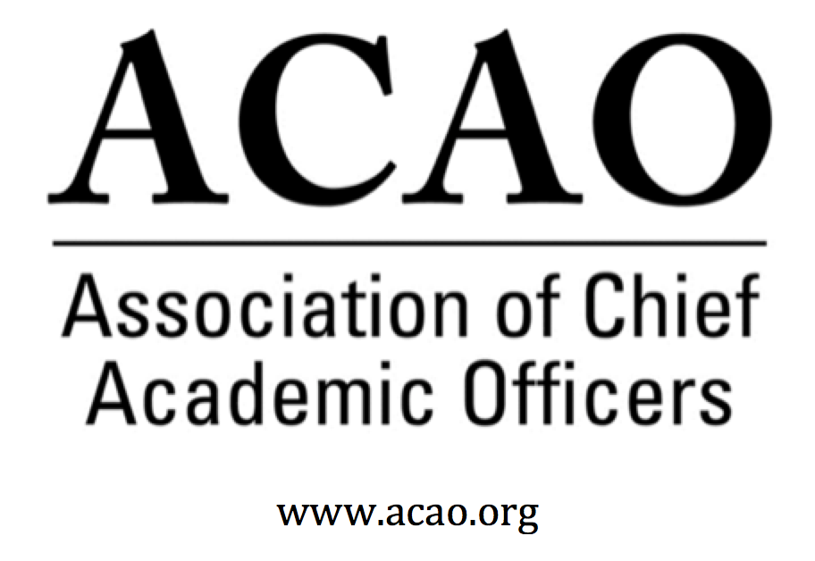

August 5, 2020: https://zoom.us/j/707742741, 2-3 PM (Eastern)

Name | Attend | Name | Attend | Invited Guests | Attend
Mary Boyd | Y | Pam Stinson | Y | Junius Gonzales | x
Gail Baker | Y | Greg Ochoa | Y | John McCarthy | Y
Kathy Johnson | Y | Peter Nwosu | Y | Michael Quillen | Y
Beth Ingram | x | Patricia Salkin | Y
Scott Newman | x | Andrew Shean | x
Laura de Abruna | Y | Constance St Germain | Y
Michael Evans | Y | Lori Werth | x
Connie Johnson | Y | Laura Woodworth-Ney | Y
 |  | April Mason/Adv Cl | Y | Doreen Murner | Y

- Review and approval of May Board Meeting minutes - M. Boyd - Call for discussion/updates.
    - June 3, 2020 Board Minutes – Motion called to approve minutes, P. Nwosu. 2nd L. de Abruna. . No discussion. Motion Passes
    - July 14, 2020 Business Meeting Minutes Motion called to approve minutes, P. Nwosu. 2nd L. de Abruna. No discussion. Motion Passes

- Executive Board recommends Heather Coltman to fill the unexpired term of vacant position (2020-2023).
K. Johnson call for discussion
Motion called to approve H. Coltman to fill unexpired term on the board, P. Salkin. 2nd L. de Abruna. No discussion. Motion Passes.

- Committee Updates

  - Digital Learning Cmte – L. de Abruna – Tyton ACAO Town Hall debrief
    - Tyton/ACAO: ACAO co-hosted a webinar based on the survey results. ACAO panelists with Tyton were: Andy Shean, Pat Salkin & Laura de Abruna. Full survey text is on the ACAO website.
    - The Digital Learning Cmte and Innovations & Strategy Cmte are working together on a Gates grant in conjunction with APLU. L. de Abruna is looking for volunteer provosts to work to create a series of 5 webinars on the COVID-19 privot. APLU will act as the fiscal agent for the distribution of funds on the grant.
    - Volunteers for the grant: Michael Evans, Constance St. Germain. Work with Doreen to avoid conflict with ACAO Town Hall dates.

  - Professional Development – D. Murner – Provost Town Halls

    - Need to schedule future Town Halls – click here for listing.

The Professional Development Committee has suggested the following 4 topics for our next schedule of Town Halls. We need moderators for each of the topics below and schedule of dates.
• Changing Landscape of Faculty Roles & Responsibilities in Higher Education
• Leading & Managing Teams Remotely
• Preparing for the 21st Century Digital Learner -- Post Spring 2020
• CAO Lessons in a Post-Pandemic World

Discussion of all the topics:
#1: Leading & Managing Teams Remotely – J. McCarthy will ask Dean, Anne Massey if she can help facilitate this Town Hall as she has expertise in this area. The tentative dates are: 8/25 or 9/8 @ 1pm ET. J. McCarthy will coordinate with A. Massey.

#2: Leading thru Disruption – B. Ingram recently facilitated a session on this topic & it was considered to bring to ACAO. Dates will be determined once Town Hall #1 is scheduled.

#3: Changing Landscape of Faculty Roles/Responsibilities – K. Johnson. Faculty evaluations through the lens of a COVID year. What inequities are created and how do we resolve them?

#4: Preparing for the 21st Century Learner-Post Spring 2020 – looking at the changing student.

#5: CAO Lessons in a Post Pandemic World – P. Stinson – What are we learning & what will we be changing?

Future Town Hall dates: 8/25; 9/8; 9/22 @ 1pm ET (Schedule is dependent on #1 date confirmation).

  - Innovation & Strategies – L. Werth
    - See above – working with DLC on Gates grant opportunity

  - Membership – G. Ochoa
    - Town Halls are a value add for ACAO and exactly what membership needed, including the blogs and the social media presence.

- Finance Committee – B. Ingram

- Advisory Council – A. Mason
Click here for ACAO Mission / Vision suggested changes
Suggested Mission Vision Changes

Council is re-thinking membership and will include current provosts as they feel it very important to have current experiences in these difficult times.
K. Johnson noted that ACE would like the blogs from ACAO to continue. A. Mason indicated the council may be willing to help with finding ideas & individuals who may be a part of the blog. The Council is raising new hypothetical questions that would be good for a blog. Ideas include:
Is Finance pushing Academics? Who Should be at the Table for the BIG decisions? What is today’s Role of Research and Discovery?

Do we want to create podcasts? ACE is very interested in ACAO providing content for the ACE Engage platform. Podcasts could be one of the modalities.

- Mason brought up the idea of mentoring new provosts. The Council will think about how to establish a process to begin.

The Executive Committee will discuss the Council’s suggested changes to the Mission & Vision, and then bring to the board. Any suggestions please email M. Boyd.

Risa Palm was suggested as a new council member. She is still working and she knows ACAO having been on the board.

- ACE update. (K. Johnson and M. Boyd) Update
MOU is signed. Need more specifics on how to move forward.

- Our next regularly scheduled board meeting is September 2, 2020 @ 2pm ET

2020 Board of Directors: Assigned Roles
Executive Committee | Director | Role/Committee | Institution | Term Ending
 | Mary Boyd | President | Berry College | 2020/2022
 | Kathy Johnson | Past President Responsibility: Chair of Nominating and  Bylaws Committees | IUPUI | 2020/2021
 | Gail Baker | President Elect  Editorial Team | University of San Diego | 2022
 | Beth Ingram | Treasurer | Northern Illinois University | 2021
 | Michael Evans | Secretary | SHNU | 2023
 | Doreen Murner | Executive Director | AMC Source | n/a
 | Laura Niesen de Abruna | PI: Digital Fellows Project  Finance Committee  Editorial Team  Digital Learning Cmte-Chair  Innovation & Strategies | York College of Pennsylvania | 2021
 | Gregory Ochoa | Chair: Membership & Communications  Digital Learning Committee | Potomac State College of West Virginia University | 2021
 | Peter Nwosu | Membership & Communications  Innovation & Strategies  Digital Learning Committee | Lehman College of CUNY | 2021
 | Connie Johnson | Professional Development  Editorial Team  Digital Learning Committee | Colorado Technical University | 2022
 | Andrew Shean | Innovation & Strategies  Digital Learning Committee | National University System | 2022
 | Lori Werth | Professional Development  Innovation & Strategies | University of Pikeville | 2022
 | Laura Woodworth-Ney | Innovation & Strategies | Idaho State University | 2022
 | Michael Quillen | Membership Committee | Rowan-Cabarrus Community College | 2022
 | Heather Coltman | Finance Committee | James Madison University | 2023
 | Scott Newman | Professional Development Committee | Oklahoma State University Institute of Technology | 2023
 | Patricia Salkin | Membership Committee | Touro College | 2023
 | Constance St. Germain | Finance Committee | Capella University | 2023
 | Junius Gonzales | Professional Development | NY Institute of Technology | 2023
 | John McCarthy | Membership Committee | UMass – Amherst | 2023
 | Pam Stinson | Professional Development | Northern Oklahoma College | 2023
 | April Mason | Chair: Advisory Council (ex officio): Ex Officio: Membership & Communications Cmte
*Additional Professional Development Committee Member: Ellen Granberg, Provost, Rochester Institute of Technology
*BJ Reed, Innovation & Strategy Committee Member: Ex officio Advisory Council rep

