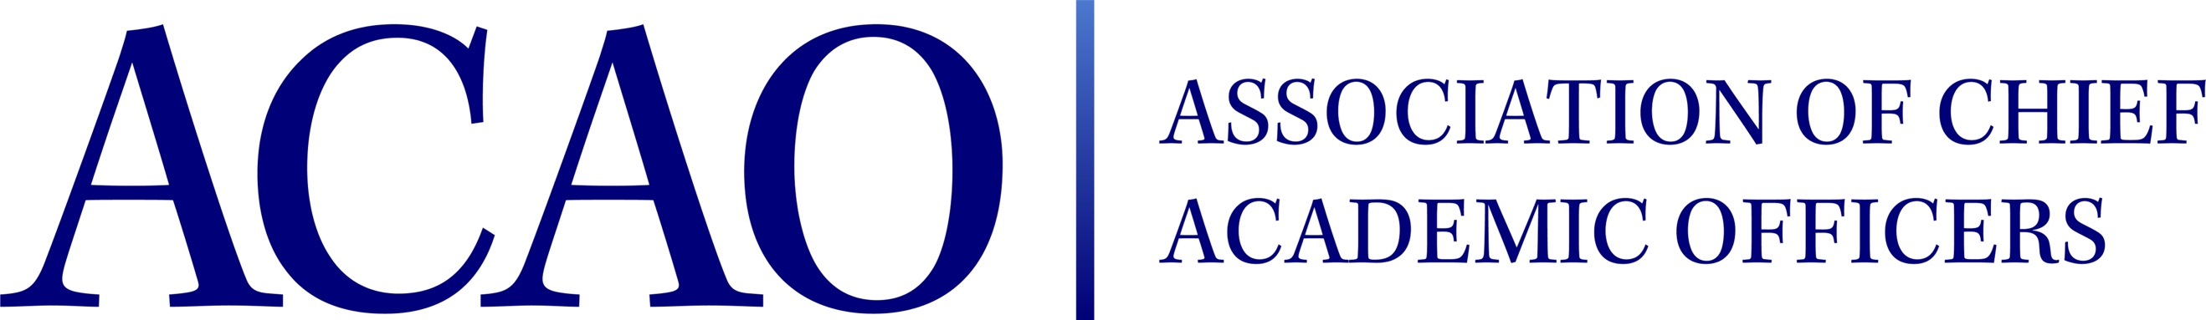
ACAO Members Business Meeting

April 14, 2023, 7:30am – 9:00am ET
Marriott Marquis Washington, DC – Capitol Room

Name | Attended |  | Name
Gail Baker |  | Pam Stinson |  |  | Robyn Parker
Beth Ingram |  | Junius Gonzales |  | x | Sacha Kopp | x
Lori Werth | x | Peter Nwosu |  | x | Michael Carr | x
Mark Ginsberg |  | Patricia Salkin |  | x
Constance St Germain |  | Laura de Abruna
Jamie Winebrake | x | Michael Quillen
Heather Coltman | x | Sophia Maggelakis
Maria Woodside Oriakhi | x | Servet Yatin |  |  | April Mason/Adv (nv) | x
Gregor Thuswaldner | x | Amy Rell |  |  | Doreen Murner (nv)
Additional members and non-members. Approximately 30 in the room

7:45 – 7:55 am: Welcome Comments made by B. Ingram
Introduce returning board members
Introduce new board members

Summary of the year:
Comments made by B. Ingram on strategic plan, membership drive, website update, blogs, job board, town halls & provosts handbook.

7:55 – 8:10am Committee reports
Finances- B. Ingram reported healthy bottom line
Membership – M. Quillen reported drive for new members and need for new members
Digital Learning & Pro D – L. de Abruna reported out on town halls and digital learning initiatives.

8:10 – 8:15am Transfer of the gavel and presidency – B. Ingram to C. St Germain

8:15 – 9:00am Members participated in various round tables & networking

2023/24 Board of Directors: Assigned Committees & Roles
Executive Committee | Director | Role/Committee | Institution | Term Ending
 | Constance St Germain | President | Capella University | 2023/2024
 | Gail Baker | Past President Responsibility: Chair of Nominating and  Bylaws Committees  (2nd yr) | University of San Diego | 2023/2024
 |  | President - Elect
 | Lori Werth | Treasurer: Chair Finance | University of Pikeville | 2025
 | Mark Ginsberg | Secretary  Membership | George Mason University | 2024
 | Doreen Murner | Executive Director | AMC Source | n/a
 | Junius Gonzales | Chair: Professional Development | NY Institute of Technology | 2023
 | Patricia Salkin | Membership Committee & Blog Series Coordinator | Touro College | 2023
 | Heather Coltman |  | James Madison University | 2023
 | Pam Stinson | Professional Development | Oklahoma State University – Oklahoma City | 2023
 | James Winebrake | Professional Development | University of North Carolina Wilmington | 2024
 | Peter Nwosu | Membership Committee  Community Engagement & Outreach | Lehman College of CUNY | 2024
 | Michael Quillen | Chair: Membership Committee | Rowan-Cabarrus Community College | 2025
 | Maria Woodside-Oriakhi | Membership Committee | University of the Bahamas | 2025
 | Gregor Thuswaldner | Handbook Task Force | Whitworth University | 2025
 | Laura Niesen de Abruna | Chair: Community Engagement & Outreach | Dominican University of Chicago | 2025
 | Sophia Maggelakis | Community Engagement & Outreach | Wentworth Inst. Of Technology | 2026
 | Servet Yatin | Membership Committee | Quincy College | 2026
 | Amy Rell | Professional Development | College for Financial Planning | 2026
 | Robyn Parker |  | Saybrook University | 2026
 | Sacha Kopp |  | Gonzaga University | 2026
 | Michael Carr |  | North Park University | 2026
 | April Mason | Chair: Advisory Council; Ex Officio member of the board: Membership Cmte |  | n/a
*BJ Reed, Community Engagement & Outreach: Advisory Council rep
*Michael Gealt, Professional Development: Advisory Council rep

