ACAO Board of Directors
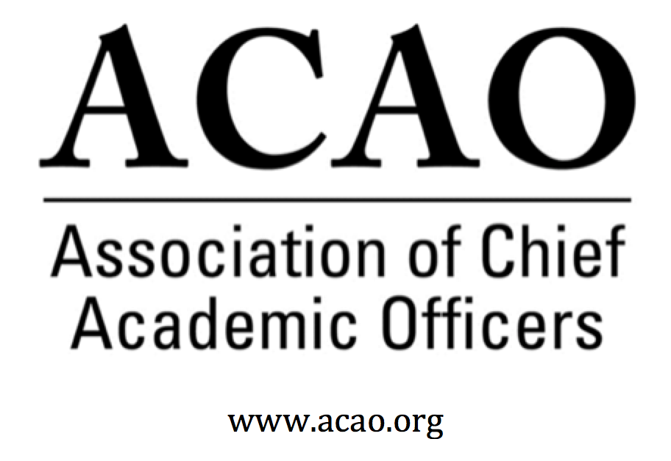

Meeting Minutes

September 5, 2018

Conference Call

Name | Attend | Name | Attend | Name | Attend
Martha Potvin | Yes | Laura de Abruna | Yes | Michaele Whelan | Yes
Kathy Johnson | Yes | Peter Nwosu | No | BJ Reed | Yes
Mary Boyd | Yes | Gregory Ochoa | No
Rick Miranda | Yes | Patricia Rogers | Yes
Kevin Carman | Yes | Beth Ingram | No
Charles Cook | No | Connie Johnson | Yes | Doreen Murner | Yes
Kelli Brown | Yes | Todd Diacon | No
Invited guests to ACAO Board Meeting: Philip Rogers, Louis Soares & Nicole Woods – all attended.
- Introductions: Martha Welcomed all to the call & gave a de-brief on the call with Kathy J & ACE, with the intended outcome of looking forward to how ACAO can work together with ACE in the future.
  - Philip Rogers, Senior Vice President – Philip discussed the importance of engaging with key partners or “friends of ACE”. ACE is looking at a select group of key partners who together will move the needle forward. ACE’s members are institutions & they view the C-suite of leaders as target members of ACE, not just the President.
  - Louis Soares, Chief Learning & Innovation Officer
  - Nicole Woods, Director
- ACE Presentation (15-20 min) – Philip and Louis gave a ppt presentation of ACE’s new initiative. Philip discussed the state of activities at ACE and the future direction. The new framework is directed by Ted Mitchell, ACE’s new president. His tenants are innovation & transparency. This is a new century for ACE. Front end of the new framework.
Innovative: Best of the past with the future in mind. Engage with a wide array of stakeholders with members at the center. Easy to manage, implement and articulate the vision. Went on over 100 “listening tours” and had conversations with all stakeholders from regional players, foundations and corporations. Core tenants are on the ACE web site.
Louis discussed publishing thought leadership resources via blogs, podcasts, briefs all as a tool kit for members via Engage Platform.
- Leadership division
- ACE Engage Learning Platform – With publishing thought leader resources there will be learning communities involving education, institutional practice and performance. And Innovation, action-based research. ACE Engage will phase out all face-to-face programs except the Fellows Program. The community learning platform will be a noodle platform. Approach is a team- based leadership approach. The engagement is structured around members of the team. Content for the platform will be created and curated by the team such as EAB, Bringing Practice to Theory, Educause
- Regional Summit Model – will raise the visibility of effective teaching such as research related to financials and student success. There will be 12 regional summits, three in each of the 4 regions.
- Q&A
Will the Engage Platform be a portal for ACAO to engage? While Engage is still in a build out, the thought is ACAO and other groups could use the Engage Platform as a portal. This is still new in concept and not yet designed.
What is the model for learning and how will it be financed? ACE is still building the pricing strategy, which is beyond dues. Maybe a series of packages a member could purchase. Collaborators may be able to use or “rent” space on the Engage Platform and be co-creators of content.
How do you see ACAO working with subscription platform? Self-managed group? Some content will be free & other could be priced with a revenue share.
How could ACAO leverage Engage for use? There are over 250 thousand managers & up in higher ed. ACE wants to find them and penetrate that market. The Platform serves from President level to Student Affairs Assoc Director level. This “team” will create a robust community for learning and curating content. Pricing will be affordable. ACE is not necessarily working with any foundations for funding. The other President Councils (AAU, ASCU, CIC, NICU, APLU) are continuing as they are. ACE views Engage as a compliment to what all the other councils are doing.
It was discussed with the apparent “openness” of Engage, it may change the conversation. Some may feel restricted knowing there are various levels engaging at the same time. ACE is aware and wants to be very intentional on building out the communities.
- ACAO Committee & General Updates (if time permits)

On Your Calendar: ACAO Winter Board Meeting
Save the Date: January 25, 2019, Washington, DC @ ACE Headquarters
Hotel and general information will be coming soon.

